Miles Shinsato

11/30/2024

Assignment 7.2 Test Cases

CSD325-A339

Assignment 7.2 Test Cases

# 1st Screenshot (Initial of City_Functions.py)

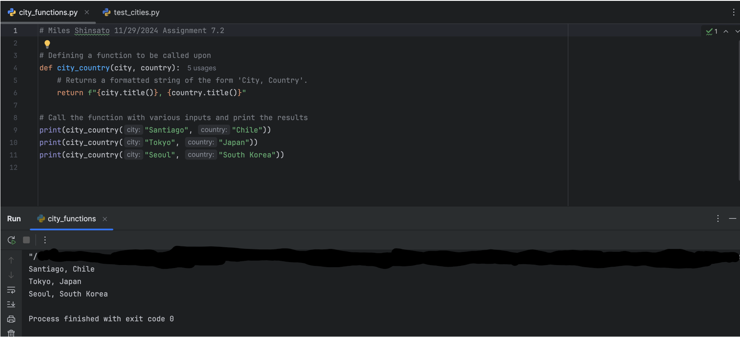

# 2nd Screenshot (Initial of Test_Cities.py)

# 3rd Screenshot (Test_Cities.py Fail After Adding Population)

# 5th Screenshot (Test_Cities.py Fail After Adding Language)

# 6th Screenshot (Test_Cities.py Pass After Adding Language)

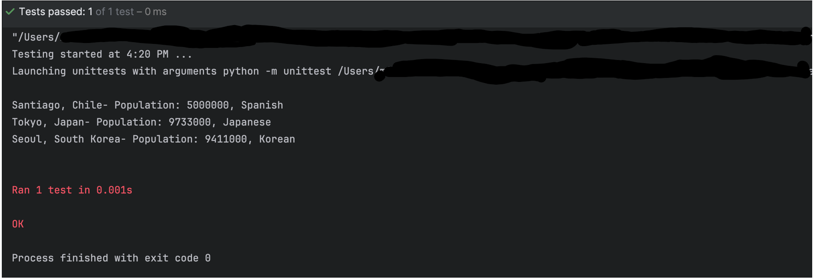

# 7th Screenshot (Final Screenshot of City_Functions.py)

